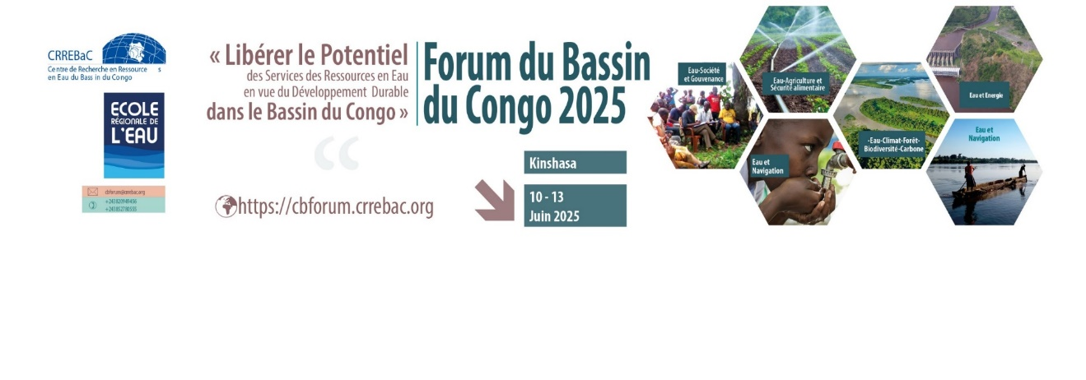

**CONGO BASIN FORUM 2025: 10-13 June 2025**

***Template for abstracts***

|  |  |
| --- | --- |
| **Field** | **Content to be filled in** |
| **Title of communication** | *(Clear, concise, informative title)* |
| **Institution** | *Name of the institution* |
| **Corresponding author** | *Name, Email* |
| **Panelistes** |  |
| **Keywords** | *3-5 keywords separated by commas* |
| **Abstract** | *Text: Maximum 500 words including:*   * *Context justification* * *Aims and objectives* * *Methodology* * *Expected outcomes* |
| **Thematic areas concerned** | *(Tick or indicate one of the forum's themes)*  ☐ Water - Climate - Forest - Biodiversity - Carbon  ☐ Water -Energy transition  ☐ Water - Navigation - Blue Economy  ☐ Water - Agriculture - Food security  ☐ Drinking water - Hygiene - Sanitation  ☐ Water - Society - Health - Private Sector - Governance  ☐ Other : ______ |